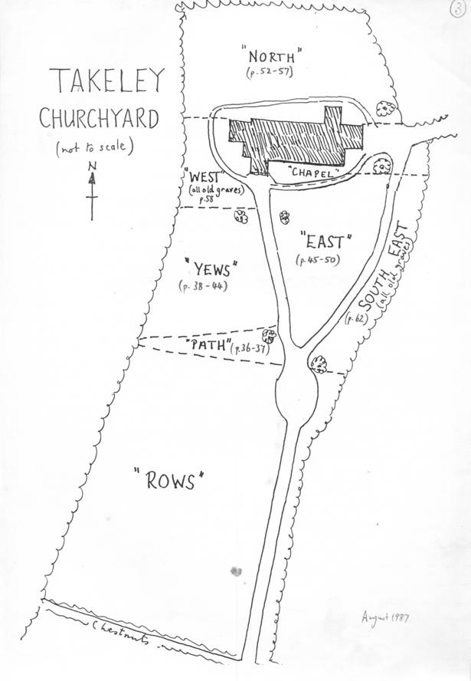

INTODUCTION
If you are reading this there is a fair chance that you are looking for a particular grave in Holy Trinity Takeley churchyard and this booklet has been produced to help you find the position of that grave.

To locate a grave it will help to know the section of the graveyard and the plot number that you are looking for. Rev. Laurie Bond has transcribed all available burial records into a Funeral Database (which can be accessed via the church website at http://holytrinitytakeley.moonfruit.com/ ) and this will greatly assist you in finding the grave where the location is known in records.

The Funeral Database (downloadable in Microsoft Excel or Access) can be searched for the name of the relative you seek and, if found, may give you the location as a Plot and Plot Number (eg. ROW 1, Plot 19 or CHAPEL Plot 6).

Please be aware that very few locations were recorded before 1875 and that finding the burial record does not necessarily mean that a grave marker of any kind is to be found. In the past many graves remained unmarked or had wooden crosses that have long since gone. Also, please remember that sometimes a memorial inscription is not at the same location as the burial. For instance a name may be recorded on a family gravestone whereas the burial could be elsewhere within the churchyard or even overseas. The Funeral Database records the position of the burial, where known.

The main plan of the churchyard is on the front page of this document. As you enter the churchyard from the car park you will be facing the church porch and facing north. For consistency, all plans in this booklet are arranged such that north is to the top of the page.

The illustrations which follow have been reproduced from the Grave Book with the kind permission of Rev. Laurie Bond. These have been amended to include additional plot numbers where the old graves were unnumbered or new graves have been created since the illustrations were first drawn.

The plan on the following page was drawn by Rev. R. Heath in 1960 and inked over in 1984 by Rev. B. Walker (who drew up the rest of these plans) to make it more legible. It shows memorials dating back to 1757.

On this plan, Rev. Heath writes; “I have not attempted a detailed plan with dates (such as can be read) of all existing tombstones. No such old plan appears to exist, if it were ever made. If attempted it might be useful for genealogist, historians and the like.”

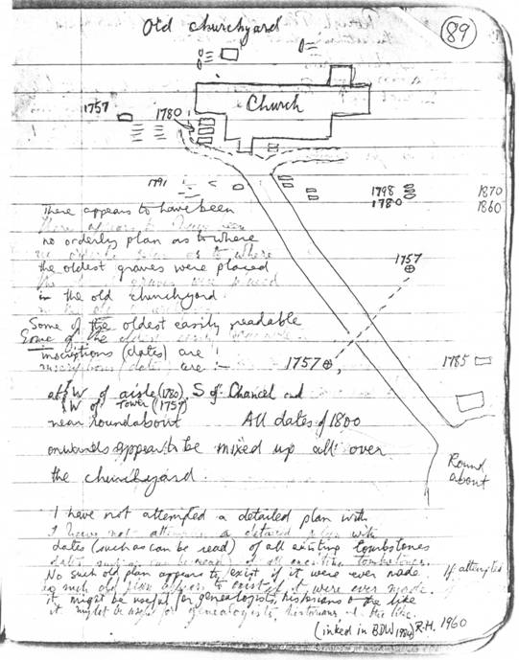
Takeley Local History Society (http://tlhs.org.uk) has now completed just such a survey. A database of memorial inscriptions is now available in Excel format from the Takeley Local History Society website. This records the position and inscription of each memorial. By matching the ID numbers between this and the funeral database it is possible to determine whether a burial in the funeral database is marked and to read the inscription and description from the memorial database.

Steve Hazon
Chairman, Takeley Local History Society
October 2005

ROWS
From the car park gateway ROWS is on your left. This is the newest addition to the churchyard and contains burials from 1875 up to 1976. ROW 1 is farthest from the path with ROW 16 against the path. The highest plot numbers are nearest the car park going down to plot number 0 about half way to the church.
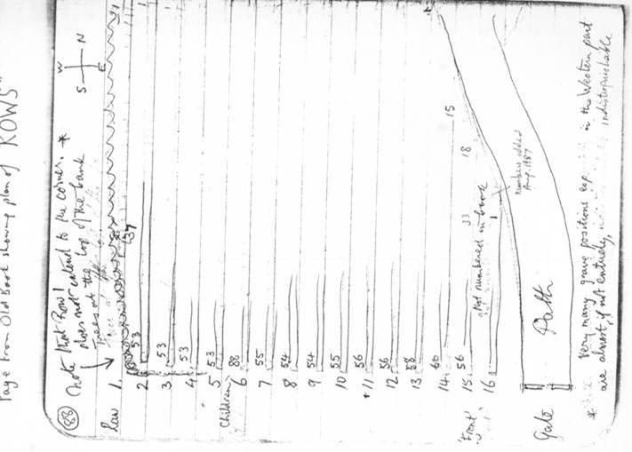


CAR PARK

War Graves
Before we started this survey we had seen it written that there were five War Graves in the churchyard. However, we have found six graves and an additional three memorials, all in ROWS. Many more of the fallen are remembered on the War Memorial outside the Silver Jubilee Hall.

Albert T. Harris, Dec 1 1914, ROW 11, 38 (Grave)
George Baynes, Aug 30 1915, ROW 11, 37 (Memorial)
John Baynes, Aug 8 1916, ROW 11, 37 (Grave)
T.C.Rolfe, 21 Aug 1916, ROW 3, 38 (Grave)
Harold Joseph Pryor, May 7 1918, ROW 7, 25 (Memorial)
Laurence Durell, Jul 15 1918, ROW 13, 16 (Memorial)
Philip Smith, 1918, ROW 12, 0 (Memorial)
Jack Wells, Aug 12 1941, ROW 10, 46 (Grave)
Bernard Charles Dennison, Oct 1 1945, ROW 14, 54 (Grave)
S.V.Rayner, Apr 12 1951, ROW 9, 48 (Grave)

PATH
PATH continues on from ROWS and is wedge shaped, filling the gap between ROWS and YEWS. PATH starts a few feet to the north of the large yew tree just after the large memorial to Rev Hart and his family.

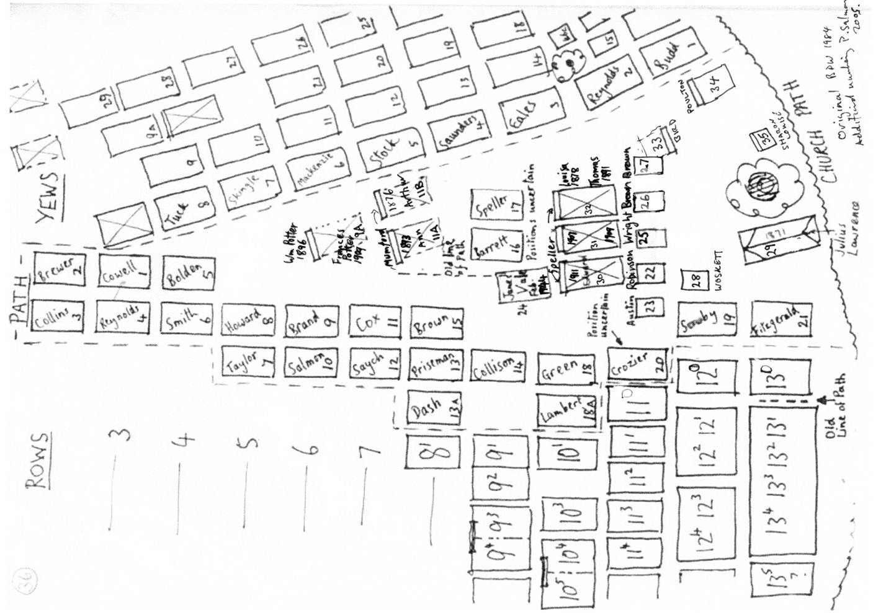

YEWS
YEWS continues northward from PATH and contains mainly burials from 1951 through to 1992 with just a few older graves
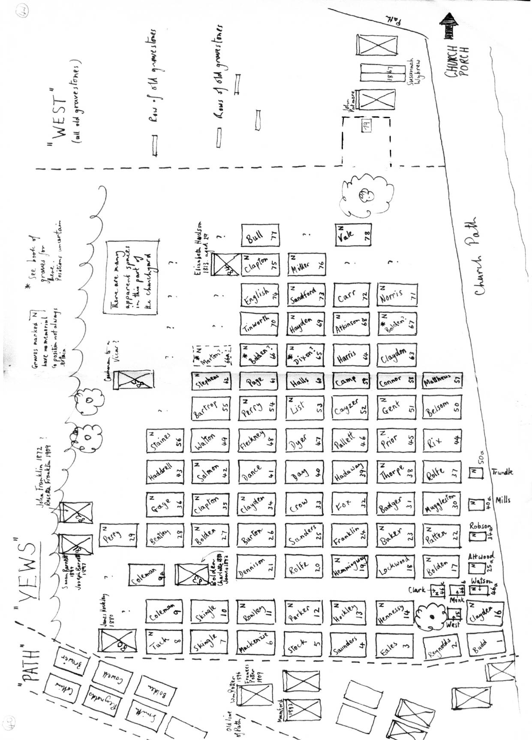

WEST
WEST contains old graves (18th and 19th century) with modern burials of ashes. Locations of graves in this area were not included in the burial book. A plan has recently been drawn of his area as no previous plan has been found. Plaques are mounted on a large stone to remember those whose ashes are buried here.
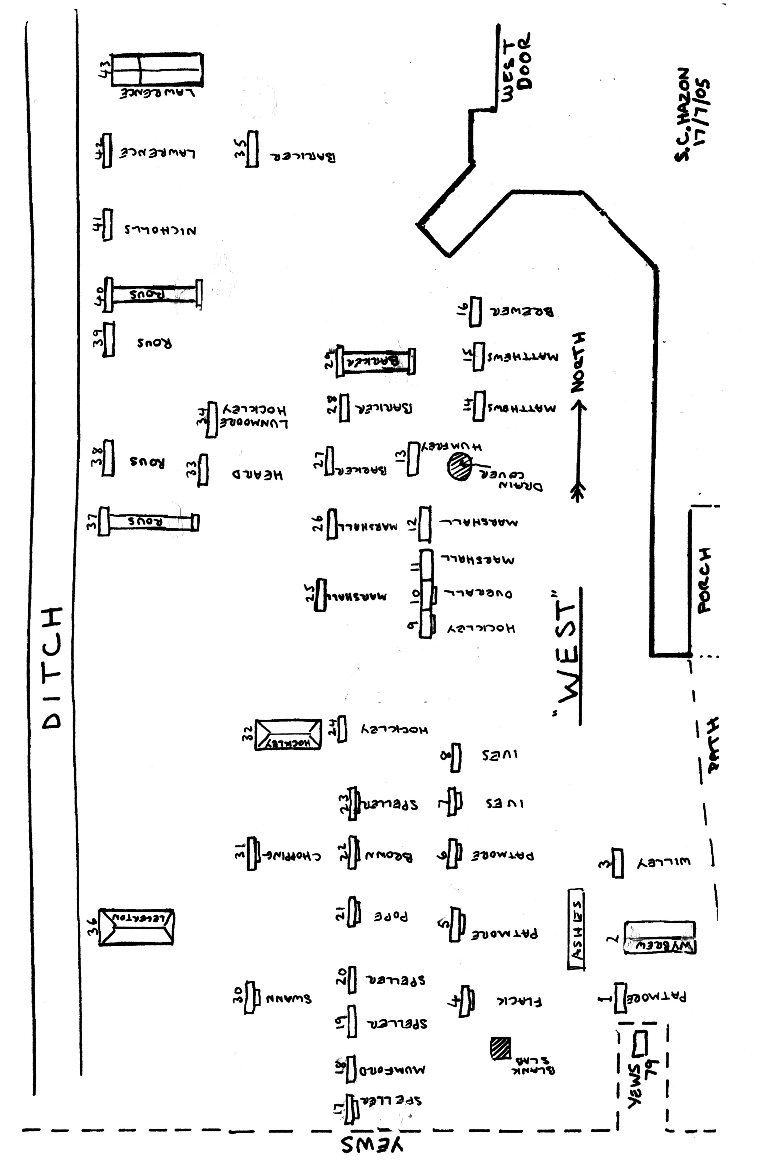

NORTH
NORTH lies to the rear of the church. Old burials date from 1808 an dmodern burials date from 1975 to the present day.
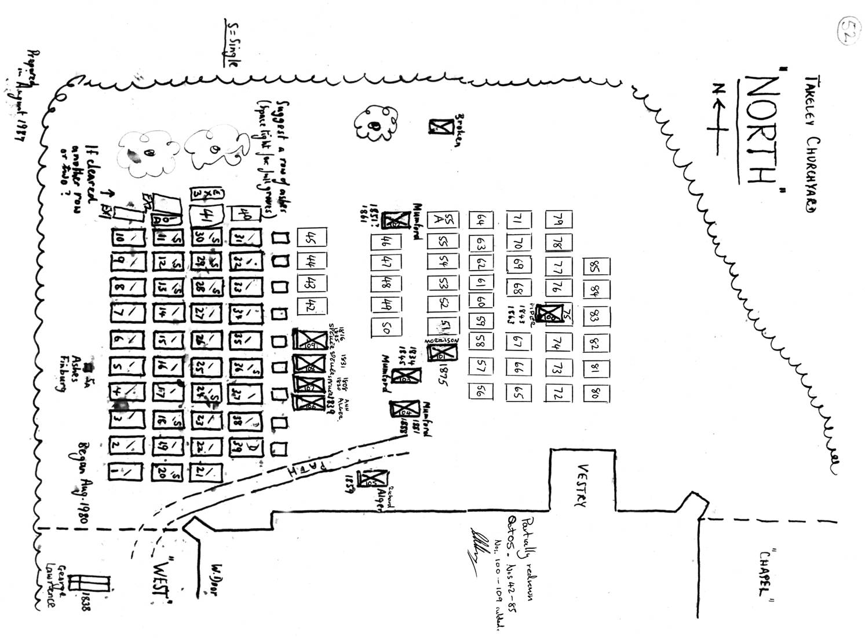

CHAPEL
Continuing around the church CHAPEL lies against the south wall of the church and contains recorded burials from 1801 to 1996.

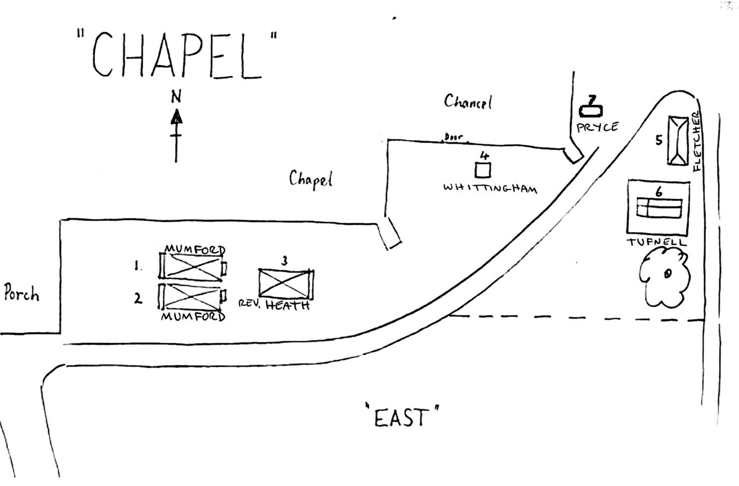

SOUTH EAST
SOUTH EAST lies to the extreme east of the graveyard between the grass path and the hedge. These are all old graves from the 19th century. Further memorials may be found if this area was cleared.
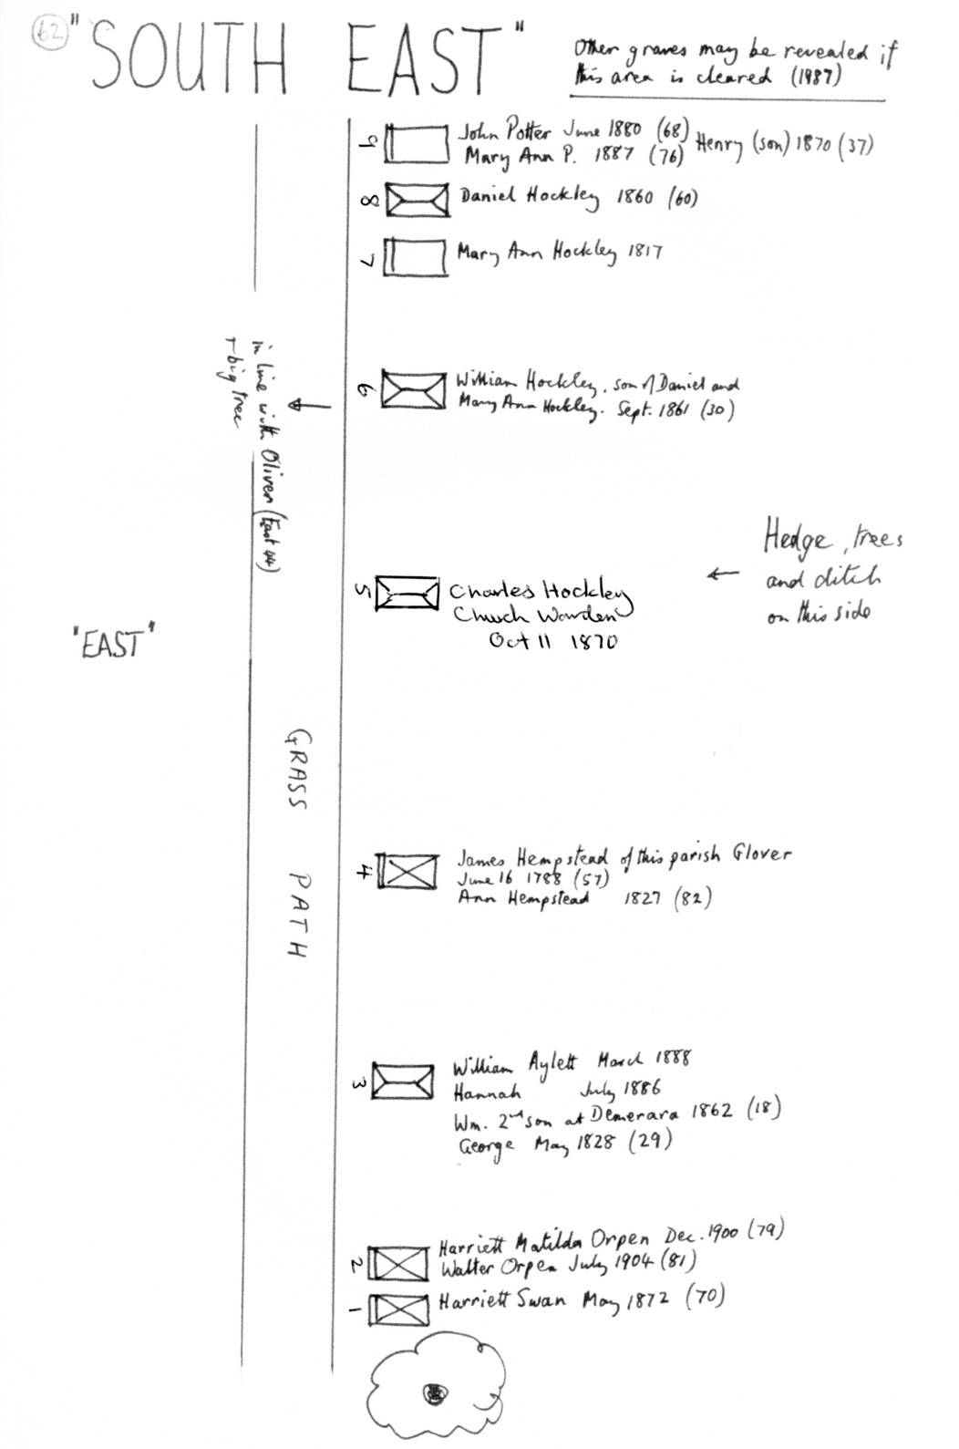

EAST
East is in the centre of the graveyard. This section contains both old (18th and 19th century) burials and modern burials from 1962 to the present day.
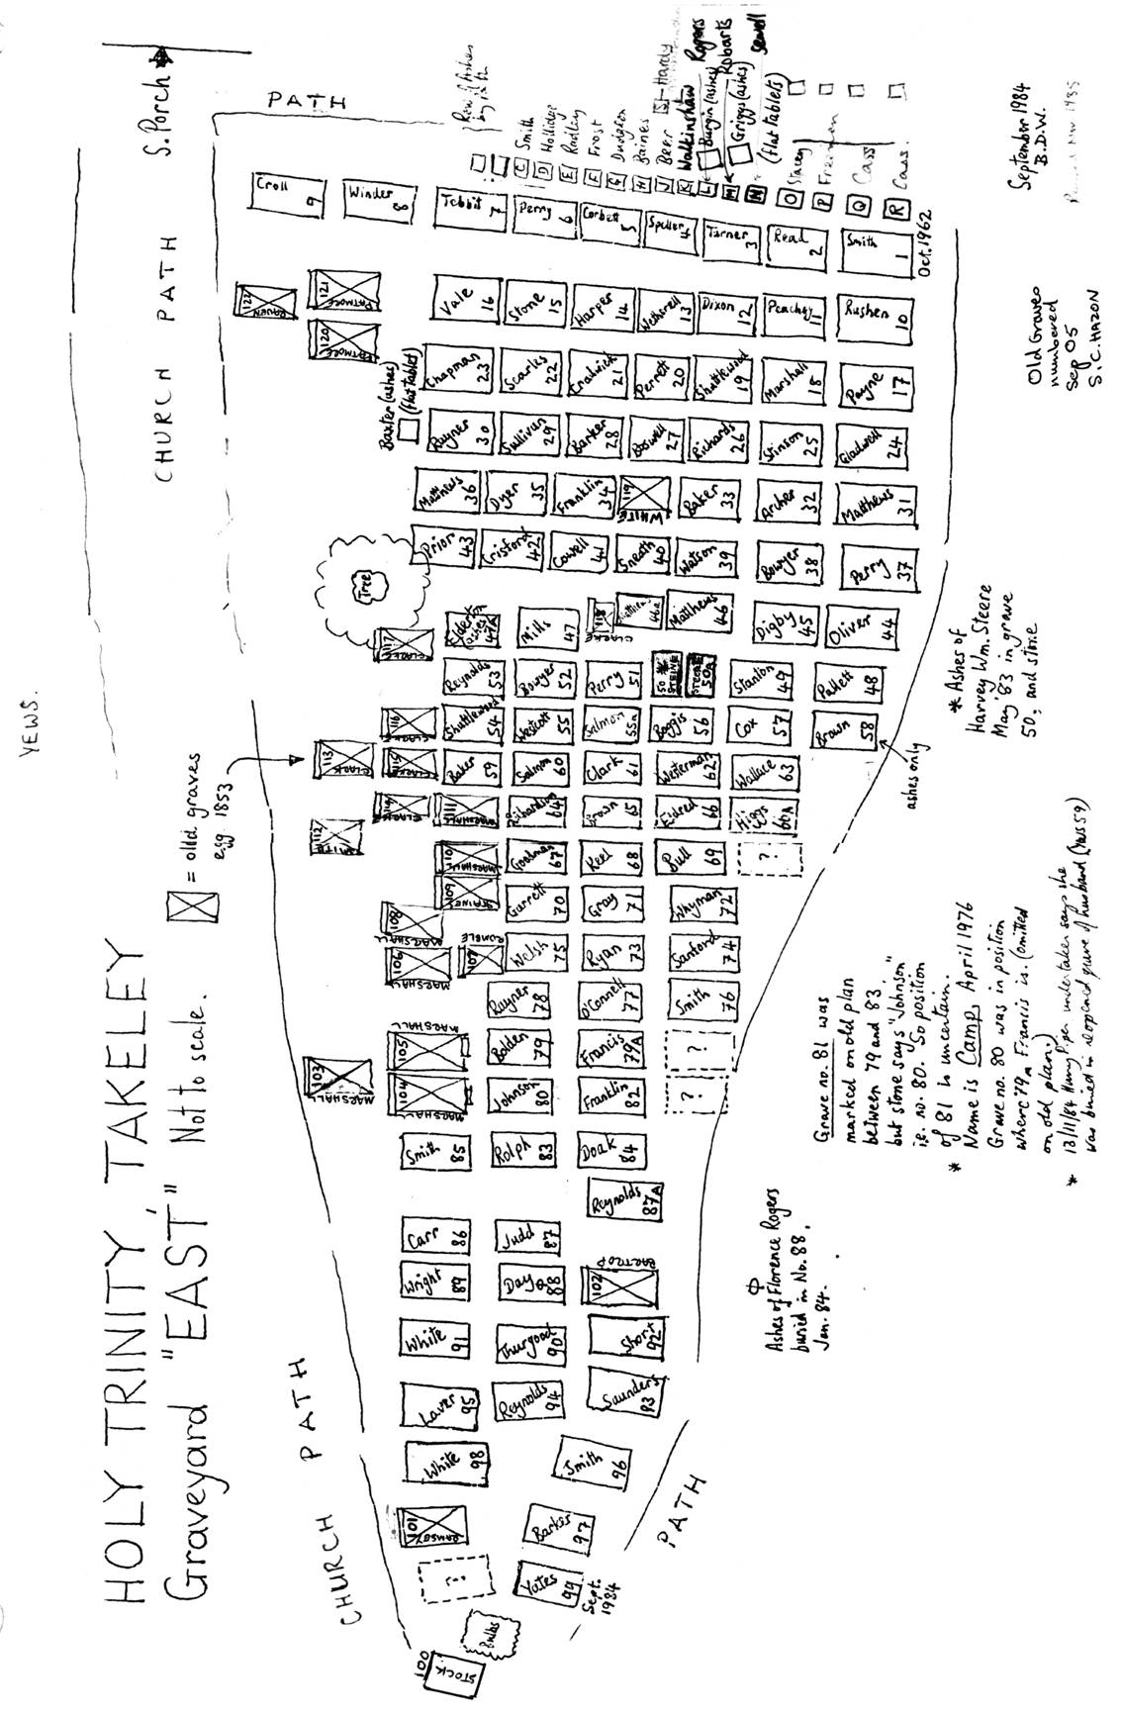

EAST ASHES
East Ashes lie between the East graves and the Chapel Graves. As the name suggests they contain ashes and date from 1982 to 2000.
